Jack Berberian

CIS 245

1/31/2022

Continue Setup Assignment for Ubuntu

Some things to know beforehand:

Sudo – is an important command which gives a user administrative or root access, which is necessary for some actions such as program installations.

Apt – is a package manager or a ‘store’ where programs can be found on Ubuntu (a version of Linux)

Install – needed to tell apt to install what you want to install

-y – can be used to skip prompts to confirm yes beforehand.

1. How to Install tmux

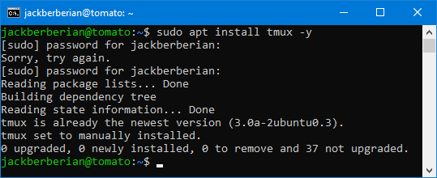

1. How to Install emacs

To install emacs, enter: sudo apt install emacs -y

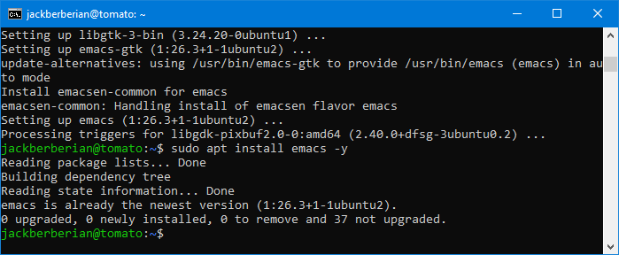

1. How to install Fail2Ban (Make sure you look through the fail2ban settings are you do the install)

To install fail2ban, enter: sudo apt install fail2ban -y

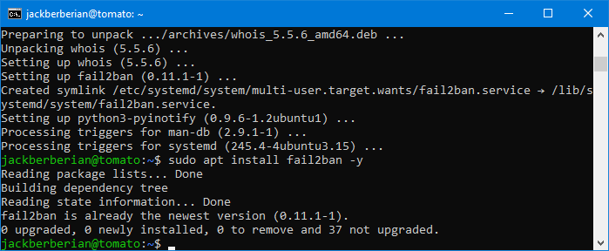

1. Install cowsay

To install cowsay, enter: sudo apt install cowsay -y

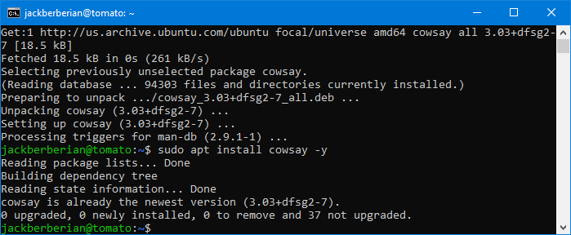

1. Install lolcat

To install lolcat, enter: sudo apt install lolcat -y

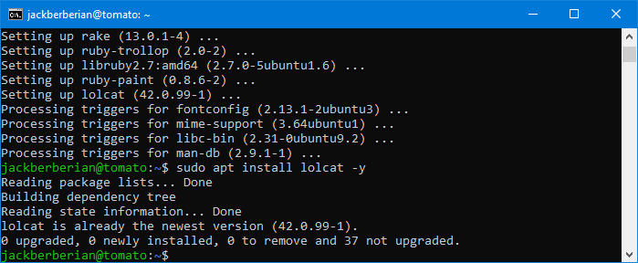

1. Update VI to vim

To update VI to vim, you can enter: sudo apt get update and then sudo apt install which will first update all programs on the system and the select the latest version of vim to install.

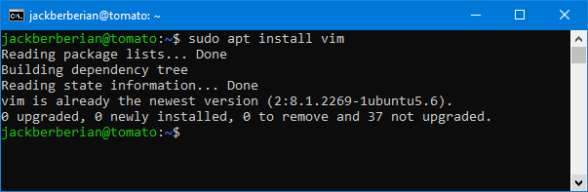

1. Update your servers if it’s needed

To update your servers, you can try the command

Sudo apt update

And then

Sudo apt upgrade

Which will look for updates on the server and then upgrade will install them.

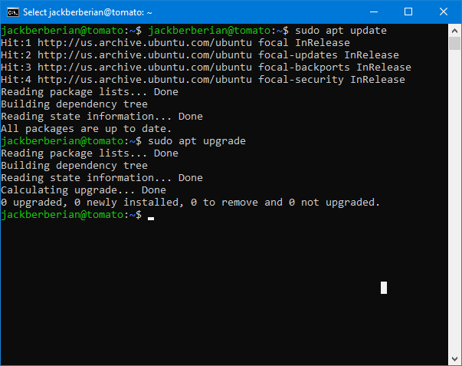

1. Another way to access file shares on Ubuntu
   1. Download and install WinSCP from <https://winscp.net/eng/docs/guide_install>
   2. Launch WinSCP and enter details for your system.

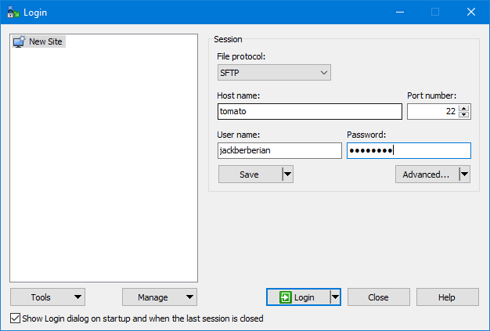

* 1. Press yes when prompted.

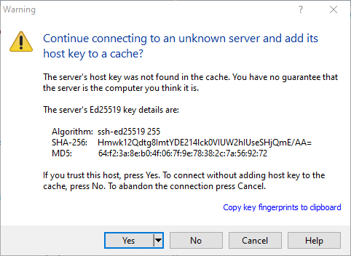

* 1. Now, you can select and transfer any files.

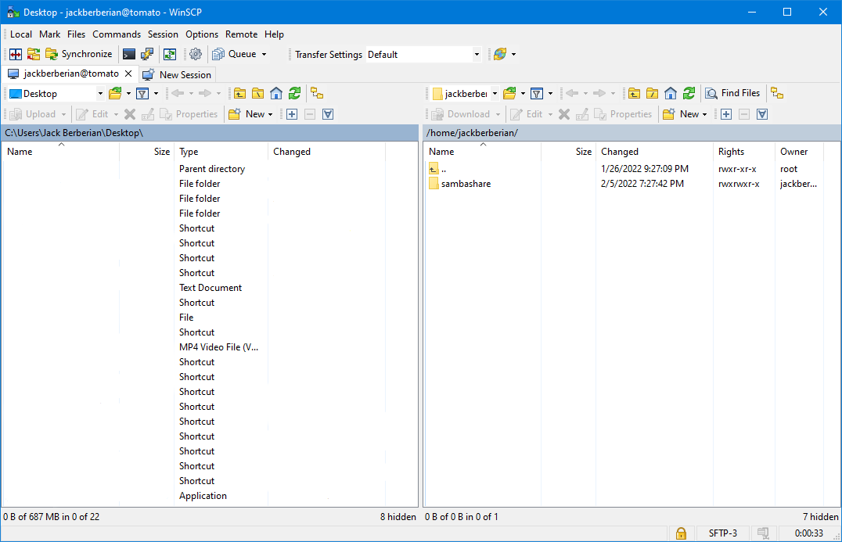

Where the Repo’s Live, How I can Find them, How to Add/Modify a Repo or PPA.

Where the Repos Live and How to Find Them

In Ubuntu, software repositories live at the file located at /etc/apt/sources.list

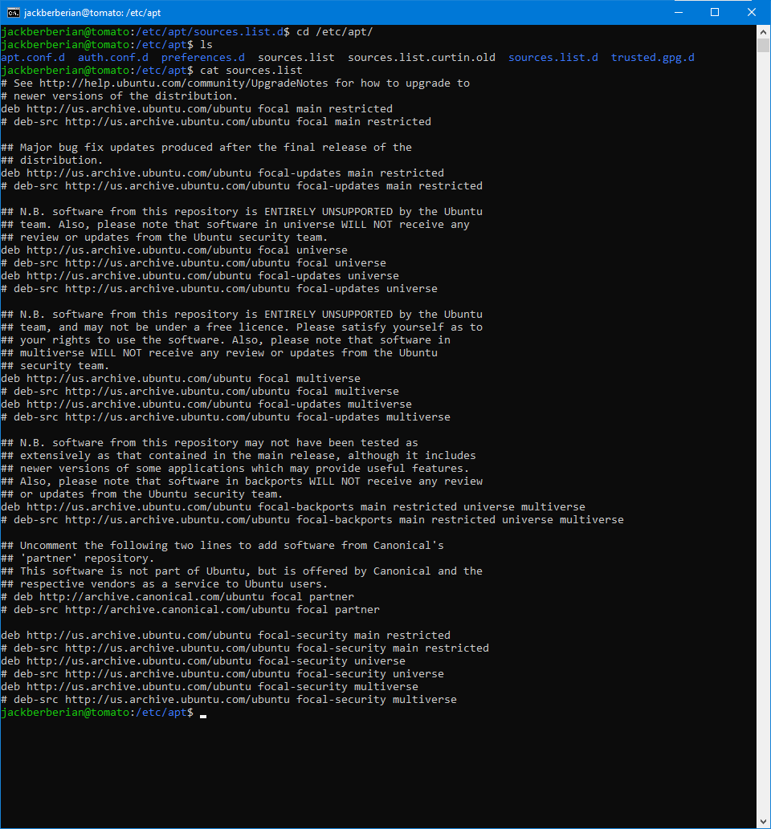

How to Add/Modify a Repo or PPA

1. To remove software, enter: sudo apt remove (name of program to remove)

Where my repos live, how can I find them, and how do I add/modify a repo or PPA.

In order to find your repos or repositories on Ubuntu, you can just enter apt list –installed and it’ll list everything that you have installed. Here’s a screenshot below of a small sample of what I have.

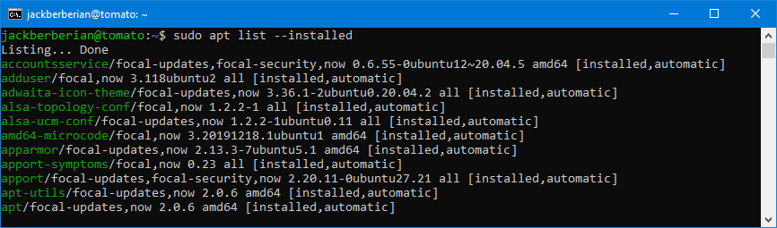

How to Add or Modify a Repo

* One of the ways that you can add a repo is that after a package is installed, you can tell it to remove something like sudo apt get purge fail2ban

